**Underground Temple:**

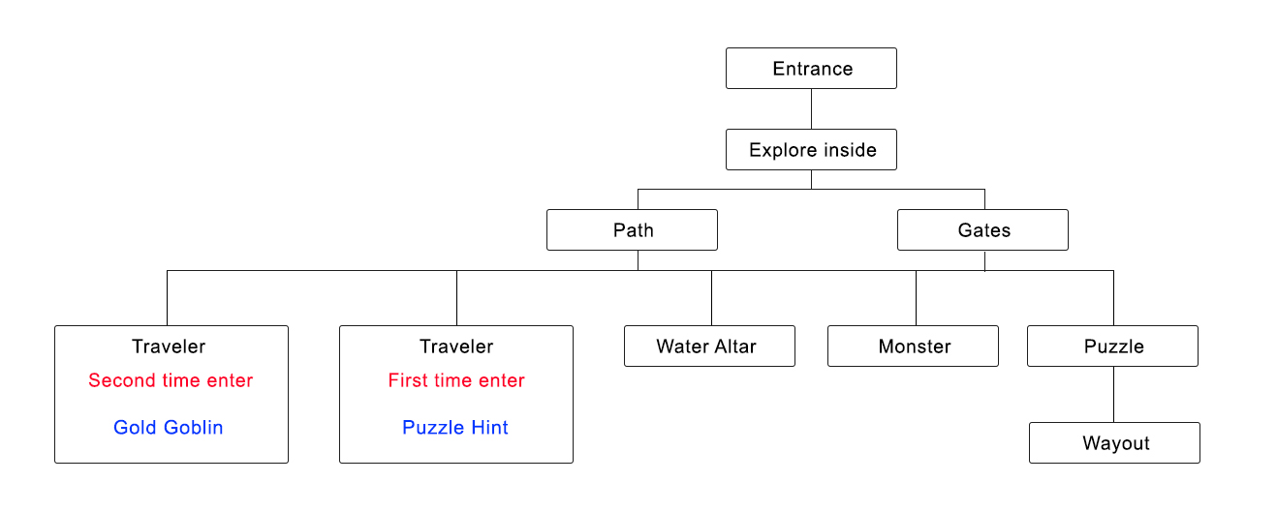

#0 On the far edge of the forest, a steep rocky wall raises high above the trees (Swipe to next) **#UT_00**

#1 You found an entrance surrounded by sculptures of fish like creatures. (Option: Explore inside Or Leave) **#UT_01**

#2 Explore inside 🡪 A long and narrow slide leads you deeper in the darkness **#UT_02**

#2 Leave 🡪 Nothing happen, END of QUEST **#UT_03**

#3 Explore inside 🡪 There are two wooden gates with mold in front of you (Chance: 50%) **#UT_04**

(Option: Open left gate Or Open Right gate)

#3 Explore inside 🡪 There are two damp and long paths in front of you (Chance: 50%) **#UT_05**

(Option: go left to the upward path Or go right to the downward path)

*PS: The above choose on paths or gates, will direct you to following events in loop until you find the way-out and get out from the Temple*

**#4 Water altar: 20% #UT_06**

You drink the water inside the altar, feel much fresh (Swipe to next)

**#4 Traveler and the hidden 1 : 20% #UT_07**

You walk into a room, see a dead body lie on the floor and it hand holding a paper note

(Option: examine the paper note or You pray to the dead…RIP)

#5 Traveler and the hidden 1 **#UT_08**

Examine the paper note🡪 Description: the puzzle in the temple should somehow related to color blending.

(Swipe to next)

#5 Traveler and the hidden 1 **#UT_09**

You pay your homage to the body…RIP 🡪 Back to #3

**#4 Traveler and the hidden 2: 2nd time draw the card #UT_10**

You walk into the room of the dead body again but you notice that the wall looks breakable with heavy impacts. (Body-Dash to the wall Or Blunt-weapon to hit the wall)

#5 Traveler and the hidden 2: **#UT_11**

Body-Dash to the wall 🡪 Rumble noise, a small chamber appeared with a treasure chest inside. (Option: Loot it or Loot it) Body-Dash will lose plenty HP

#5 Traveler and the hidden 2: **#UT_12**

Blunt-weapon to hit the wall 🡪 Rumble noise, a small chamber appeared with a treasure chest inside. (Option: Loot it or Loot it) Blunt-weapon hits lose a little HP

#6 Traveler and the hidden 2 **#UT_13**

Loot it 🡪 A box of shiny gold coins. (Gold +300) 🡪 Back to #3

**#4 Encounter Monster: 40% First time #UT_14**

A Fish tribe warrior appears (Option: Talk or Attack)

#5 Encounter Monster: 40% First time **#UT_15**

Talk 🡪 It don’t listen to you, you two have a battle. And it runs (Lose some HP) **#UT_15**

Attack 🡪 You two have a battle, (Lose some HP) **#UT_16**

If win …the fish warrior dead under your attack, you pick its.. (Option: weapon/armor). **#UT_17&21**

You have obtain fish warrior’s Weapon **#UT_18**

You have obtain fish warrior’s Armor **#UT_19**

If Lose… 🡪 Your enemy gives you a lethal attack, you are dead. **#UT_20**

**#4 Encounter Monster: 25% Second time**

A Fish tribe monster appears, you want to (Option: Talk or Attack)

Talk (and previous Talk) 🡪 Your enemy gives you a lethal attack, you are dead. **#UT_21**

Attack (and previous Talk) 🡪 You two have a long battle, it begs you to let him go. (Option: kill him or let him go )

Kill him = #UT_17&21

Let him go = the warrior gives you the Eyes of Jade (Bring player back to life again, one-time) for gratitude #UT_22

**#4 Puzzle Room: 50% and with 3 #4 events occur forehead**

You walk into a room with a transparent eyes stone statue holding two crystals balls. **#UT_23**

It seems like you can swap the color balls(red, blue, yellow) on the ground with the crystal balls on its hands. **#UT_24**

If experienced #UT_08, then #UT_25 appeared: The paper note from dead body said something about this puzzle #UT_25

You may move the color balls freely and swipe left or right to confirm. #UT_26

If they put Blue and Yellow, then they pass. If not the floor will collapse

Pass 🡪 a secret path appeared behind the statue #UT_27

Fail 🡪 the floor collapse, you die…Gameover #UT_28

#7 Puzzle Room: wayout

Go in 🡪 You feel both wind and light are summoning you to the wayout in different direction (Option: go to the light or go to the wind) #UT_29

#8 Puzzle Room

Go to the light 🡪 It is an illusion, the fish boss’s lantern caught you attention, you are too weak to fight such legendary creature, it consumed you …Game over #UT_30

#8 Puzzle Room

Go to the Wind 🡪 it is the wayout to the forest (End of QUEST) #UT_31